PPLS HYDERABAD REPORT

Date: 8th August 2019
Venue: Niloufer hospital for Women and Children, Hyderabad
Workshop conducted as a part of ISACON SOUTH 2019
Faculty: Dr Sandhya Yaddanapudi, Dr Chandrika Y.R, Dr Ekta Rai, Dr Aavula Muralidhar, Dr Vibhavari Naik
Delegates: 30
Time scheduled: 8 am to 5 pm

Preparations: Dr Murali took permission to conduct this workshop as a part of ISACON SOUTH 2019. It was discussed with Dr Elsa and decided not to conduct TOT along with this workshop. Flyers were made and circulated 10-12 weeks in advance. It was not possible to select the delegates and we anticipated more of post graduates as it was linked with south zone conference. Dr Elsa selected the faculty and chalked out the scientific program. Communication with the faculty regarding the course content and requirements for the skill station began 2-3 weeks in advance. IAPA Telangana was informed and office bearers invited. WhatsApp group was created for communicating with the delegates and the scientific program was shared with a few reminders to attend on time. The Niloufer hospital team under the leadership of Dr Shiva and Dr Murali took lot of efforts in organising the venue. Dr Vibha visited twice for helping. The out-station faculty reached a day prior to settle in. The previous evening review of the venue and the arrangements was done by Dr Ekta, Dr Murali and Dr Vibha. The organising committee of ISACON SOUTH requested addition of few more delegates previous night and the same was done to make it a total of 30 delegates.

Program: Registrations with light breakfast started at 8 am. Most delegates were in by 8.30 am despite previous communication. IAPA Telangana office bearers and Dr Prabhavati also came to encourage us. The program started at 8.35 am with introduction to the program by Dr Vibha along with housekeeping announcements, followed by Saraswati vandana and lamp lighting. The simple but beautiful flower decoration of the podium could not be missed. The scientific program started with pre-test MCQs. Few delegates who came in late, and missed the MCQs, were advised to take only the post-test. The organisers of ISACON SOUTH visited to overview the conduct of the workshop. The program was conducted as per the sequence of talks, small group discussions and skill stations. All the three halls were prepared with screens for connecting laptops, but the mike system arrangement was required only for the main hall. There were some glitches for connecting the laptops before two talks, since each speaker had to connect their respective laptops for the presentations. They were resolved. The members were divided into three groups for rotations. The faculty not involved in active teaching helped in time-keeping and movement of delegates as per the flow. The interactive case discussions for the small groups saw many delegates interacting and clarifying their doubts with faculties, which also spilled over the breaks. Hot tea, coffee and Hyderabad special Osmania biscuits were served during tea breaks and simple, tasty local cuisine lunch was served during lunch break. The wash-rooms were cleaned a couple of times and particularly after each break. Post lunch, skill stations were arranged with equipment in the respective halls. The delegates were allowed hands-on experience during the skill station, which they enjoyed (through unofficial communication). The role play of 'Breaking bad news' was volunteered by the delegates, but Dr Ekta and Dr Murali had to chip-in to give it the intended direction. After all sessions, the post-test MCQs were run and collected along with the feedback forms. The correct answers of the MCQs were also shared with the delegates. The faculty was thanked and acknowledged for their time and effort with mementoes from ISACON SOUTH 2019. Following which the certificates were handed over to both the faculty and the delegates.

Post-program: The organisers as well as faculty was congratulated for the successful conduct of the program. The feedback forms, MCQ answer sheet was taken by Dr Vibha for analysis and Dr MSRC Murthy invited the faculty and IAPA Telangana office bearers for Hyderabadi biryani dinner.

Finances: The PPLS workshop was conducted under the aegis of ISACON SOUTH 2019 and hence the remuneration generated from the delegates as well as the expenses incurred, including faculty stay and food was managed by the conference.

Feedback: Informal feedback was collected from the delegates during the session-breaks to check the speed and usefulness of the content. Also, inputs were taken from the faculty regarding the adequacy of timing and content for the present audience. After the program, the faculty critically analysed the conduct of workshop and gave further inputs as mentioned below. Similarly, the delegate feedback forms were analysed and summarised as below. Feedback forms could be collected only from 28 delegates and few areas in forms were found blank. The average score of candidates' pre-test was 8.15/20 and post-test was 13.55/20. Eight delegates could not give pre-test as they were few minutes late and their scores were not added to the above.

A. Feedback by the faculty:
1. The faculty had to custom the content for the delegates who were mostly post graduates
2. Time seemed less, particularly for the first set of small group discussions
3. The role play should be done by a mix of delegates and faculty rather than delegates alone
4. We could have collected feedback forms while handing over certificates to make sure that all forms got collected

B. Feedback by the delegates:
SNO | Topic/Talk | Strongly Agree | Agree | Neutral | Disagree | Strong Disagree | Not Applicable
 | The content is comprehensive | 15 | 7 | 2 | 0 | 0 | 0
 | I would like to have more talks | 9 | 10 | 6 | 2 | 0 | 0
3. | I would like more interactive case discussions | 11 | 7 | 8 | 1 | 0 | 0
4. | I would like more skills station | 15 | 7 | 4 | 1 | 0 | 0
5. | The duration of the workshop is just right | 11 | 13 | 2 | 0 | 0 | 0
6. | This workshop is useful for my clinical practice | 22 | 5 | 1 | 0 | 0 | 0
7. | I would recommend this workshop for medical and nursing staff involved in perioperative care of children | 17 | 9 | 2 | 0 | 0 | 0
8. | Further comments | Very useful, Good, Helpful, Balanced, Thank you

Talk: Common causes of peri-operative cardiac arrest: Dr Chandrika
 |  | Strongly Agree | Agree | Neutral | Disagree | Strong Disagree | Not Applicable
 | The content was relevant to my work. | 21 | 5 | 1 | 0 | 0 | 0
 | The speaker communicated effectively. | 18 | 6 | 1 | 0 | 0 | 0

Talk: Recognition of critically ill child: Dr Ekta
 |  | Strongly Agree | Agree | Neutral | Disagree | Strong Disagree | Not Applicable
 | The content was relevant to my work. | 22 | 5 | 0 | 0 | 0 | 0
 | The speaker communicated effectively. | 22 | 4 | 0 | 0 | 0 | 0

Talk: Updates on paediatric resuscitation: Dr Murali
 |  | Strongly Agree | Agree | Neutral | Disagree | Strong Disagree | Not Applicable
 | The content was relevant to my work. | 23 | 4 | 0 | 0 | 0 | 0
 | The speaker communicated effectively. | 21 | 5 | 0 | 0 | 0 | 0

Talk: Effective teamwork during crises: Dr Vibha
 |  | Strongly Agree | Agree | Neutral | Disagree | Strong Disagree | Not Applicable
 | The content was relevant to my work. | 23 | 4 | 0 | 0 | 0 | 0
 | The speaker communicated effectively. | 21 | 5 | 0 | 0 | 0 | 0

Talk: Recognition and Management of Arrhythmias: Dr Sandhya
 |  | Strongly Agree | Agree | Neutral | Disagree | Strong Disagree | Not Applicable
 | The content was relevant to my work. | 23 | 5 | 0 | 0 | 0 | 0
 | The speaker communicated effectively. | 20 | 6 | 0 | 0 | 0 | 0

Talk: Breaking bad news: Dr Vibha
 |  | Strongly Agree | Agree | Neutral | Disagree | Strong Disagree | Not Applicable
 | The content was relevant to my work. | 23 | 5 | 0 | 0 | 0 | 0
 | The speaker communicated effectively. | 22 | 5 | 0 | 0 | 0 | 0

Small group: Recognition of airway at risk: Dr Murali
 |  | Strongly Agree | Agree | Neutral | Disagree | Strong Disagree | Not Applicable
 | The content was relevant to my work. | 23 | 4 | 1 | 0 | 0 | 0
 | The speaker communicated effectively. | 21 | 4 | 1 | 0 | 0 | 0

Small group: Fluid resuscitation in the hypovolemic child: Dr Chandrika
 |  | Strongly Agree | Agree | Neutral | Disagree | Strong Disagree | Not Applicable
 | The content was relevant to my work. | 21 | 6 | 1 | 0 | 0 | 0
 | The speaker communicated effectively. | 18 | 7 | 1 | 0 | 0 | 0

Small group: Desaturation in the recovery: Dr Ekta
 |  | Strongly Agree | Agree | Neutral | Disagree | Strong Disagree | Not Applicable
 | The content was relevant to my work. | 22 | 5 | 0 | 0 | 0 | 0
 | The speaker communicated effectively. | 22 | 4 | 0 | 0 | 0 | 0

Small group: Tight bag: Dr Sandhya
 |  | Strongly Agree | Agree | Neutral | Disagree | Strong Disagree | Not Applicable
 | The content was relevant to my work. | 19 | 8 | 0 | 0 | 0 | 0
 | The speaker communicated effectively. | 16 | 10 | 0 | 0 | 0 | 0

Small group: Unexpected cardiac arrest in infant after a caudal: Dr Vibha
 |  | Strongly Agree | Agree | Neutral | Disagree | Strong Disagree | Not Applicable
 | The content was relevant to my work. | 22 | 6 | 0 | 0 | 0 | 0
 | The speaker communicated effectively. | 20 | 7 | 0 | 0 | 0 | 0

Small group: Sudden fall in EtCO2 intra-operatively: Dr Ekta
 |  | Strongly Agree | Agree | Neutral | Disagree | Strong Disagree | Not Applicable
1. | The content was relevant to my work. | 25 | 3 | 0 | 0 | 0 | 0
2. | The speaker communicated effectively | 24 | 3 | 0 | 0 | 0 | 0

Skills: Recognition and management of arrhythmias: Dr Sandhya/Dr Vibha
 |  | Strongly Agree | Agree | Neutral | Disagree | Strong Disagree | Not Applicable
 | The content was relevant to my work. | 22 | 4 | 1 | 0 | 0 | 0
 | The speaker communicated effectively. | 20 | 5 | 1 | 0 | 0 | 0

Skills: Effective CPR and teamwork: Dr Ekta/Dr Chandrika

 |  | Strongly Agree | Agree | Neutral | Disagree | Strong Disagree | Not Applicable
 | The content was relevant to my work. | 21 | 5 | 1 | 0 | 0 | 0
 | The speaker communicated effectively. | 20 | 7 | 1 | 0 | 0 | 0

Skills: IV access station: Dr Murali
 |  | Strongly Agree | Agree | Neutral | Disagree | Strong Disagree | Not Applicable
 | The content was relevant to my work. | 21 | 3 | 2 | 0 | 0 | 0
 | The speaker communicated effectively. | 22 | 3 | 2 | 0 | 0 | 0

Event Memories:

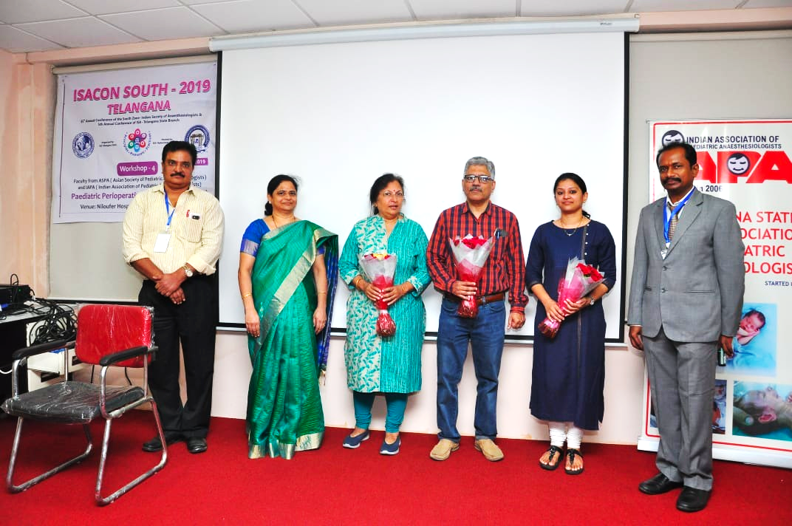
Organisers with IAPA Telangana office bearers
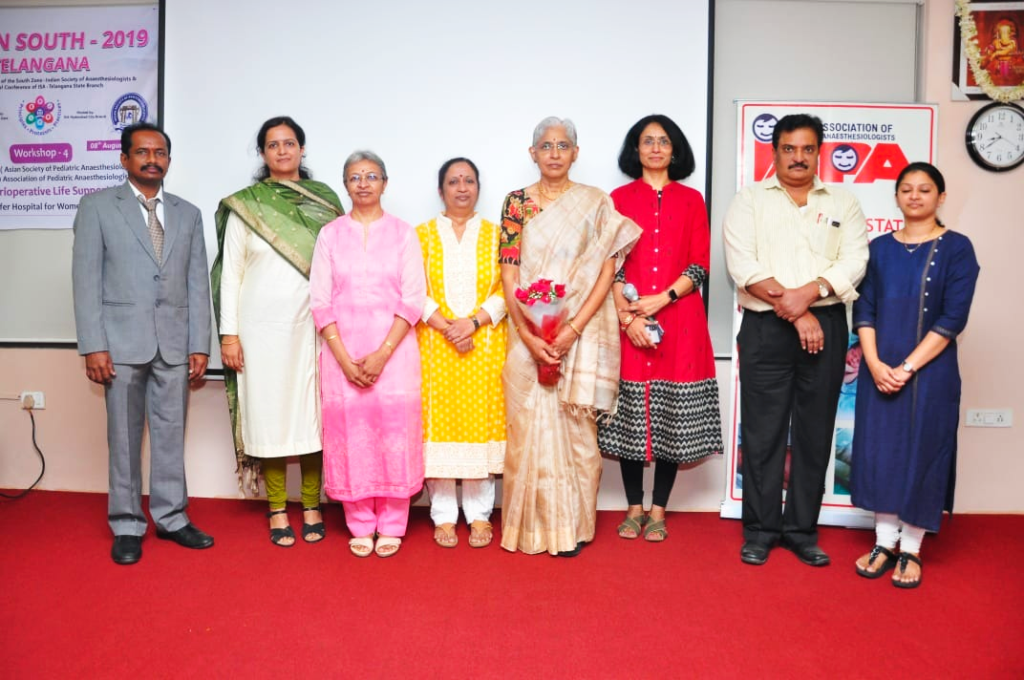
Faculty with Dr Prabhavati Mam

Lamp lighting ceremony

The audience during a talk

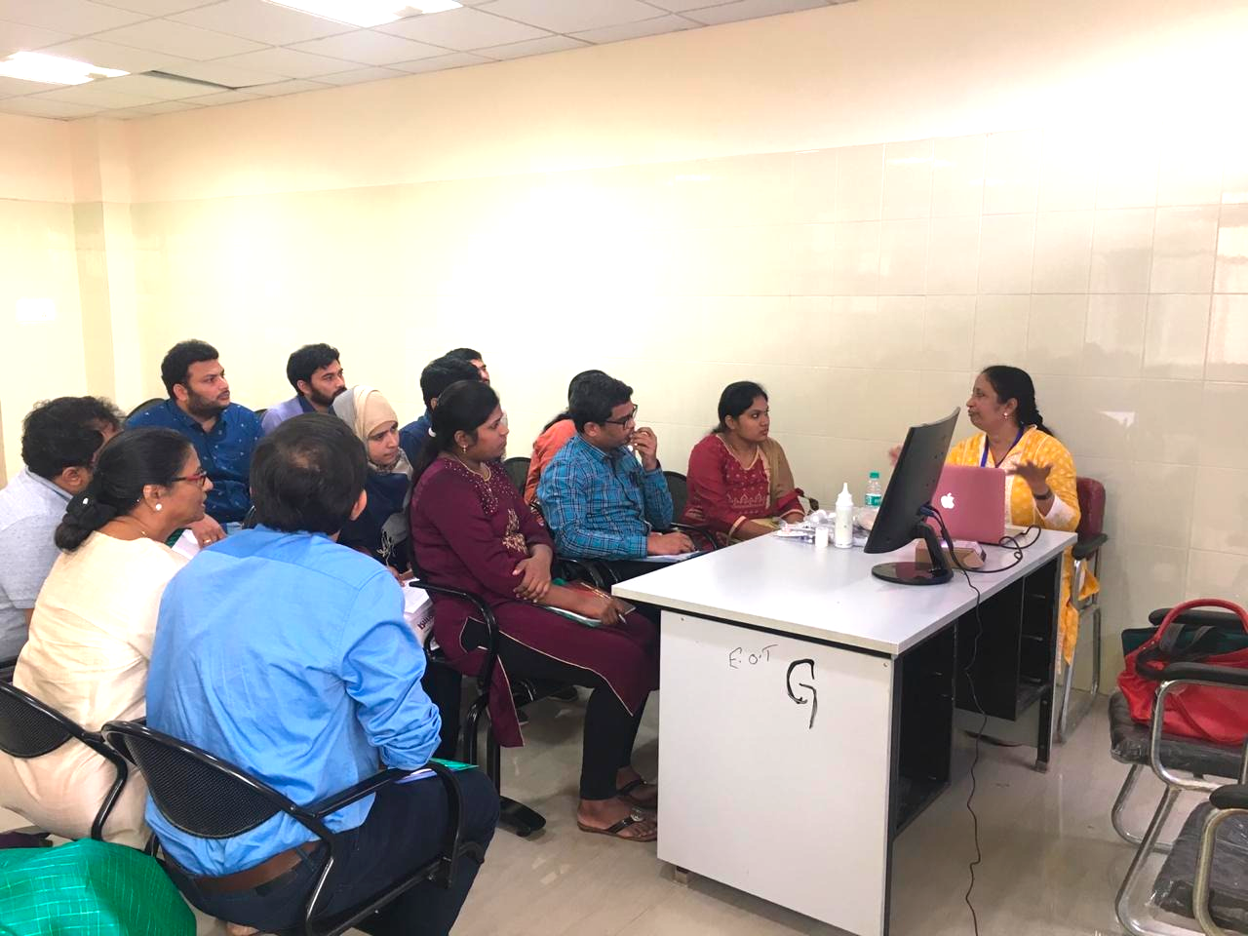
Dr Chandrika conducting a small group discussion

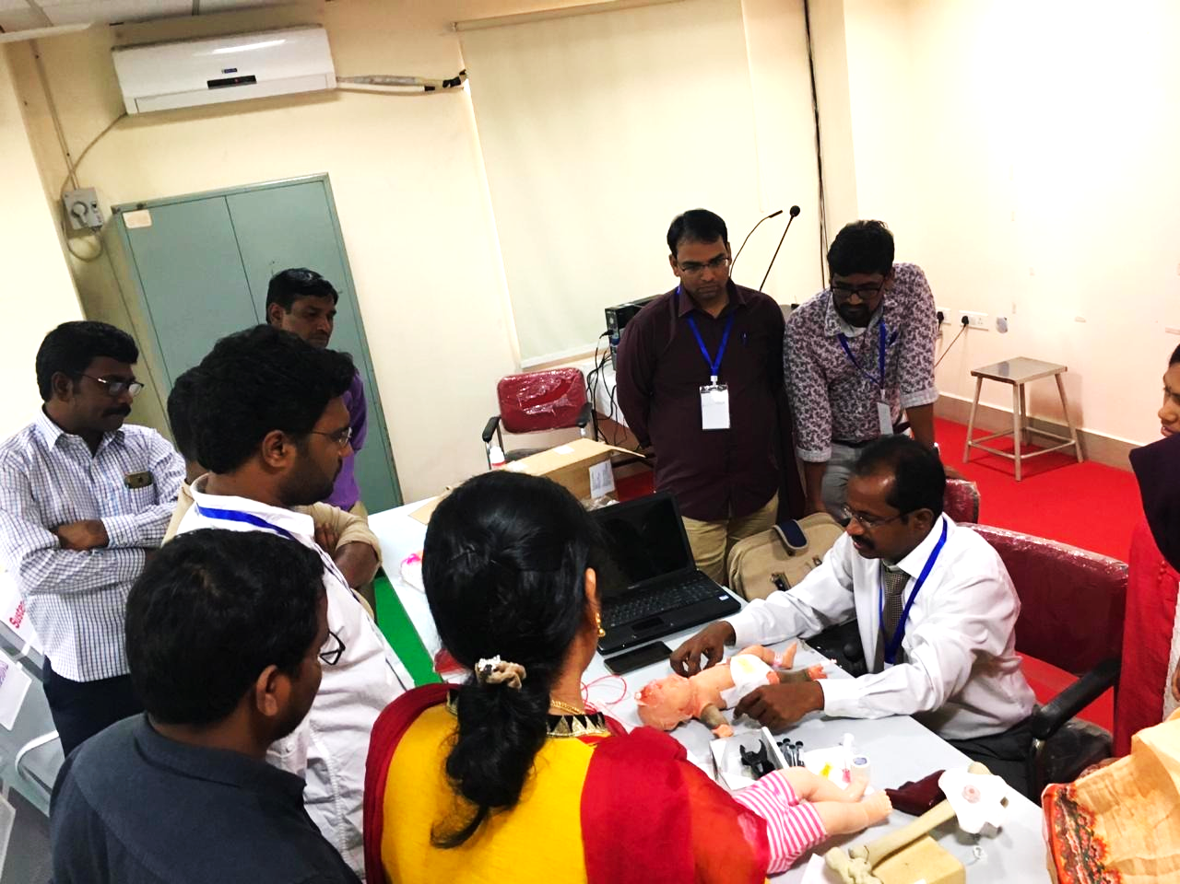
Dr Murali demonstrating on skill station

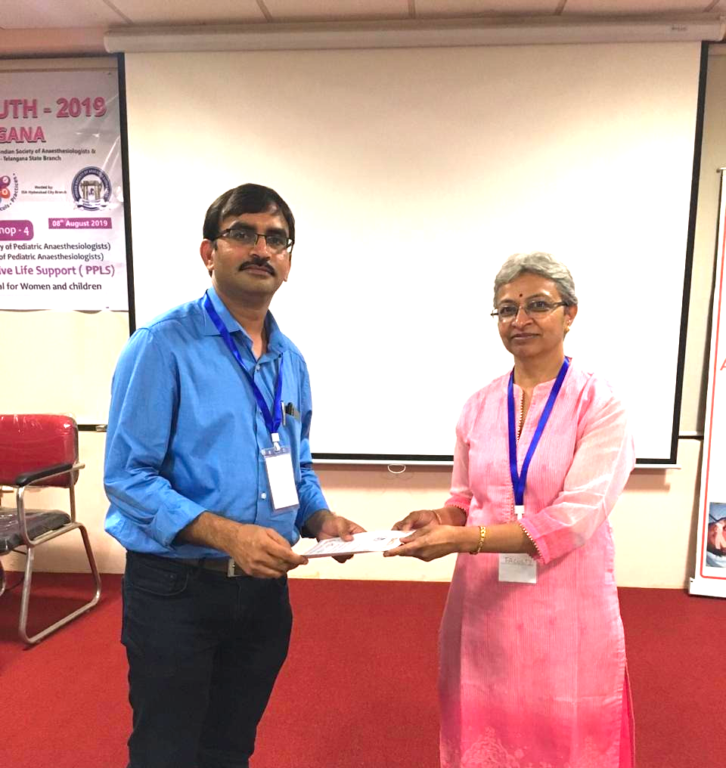
Dr Sandhya handing over the certificate

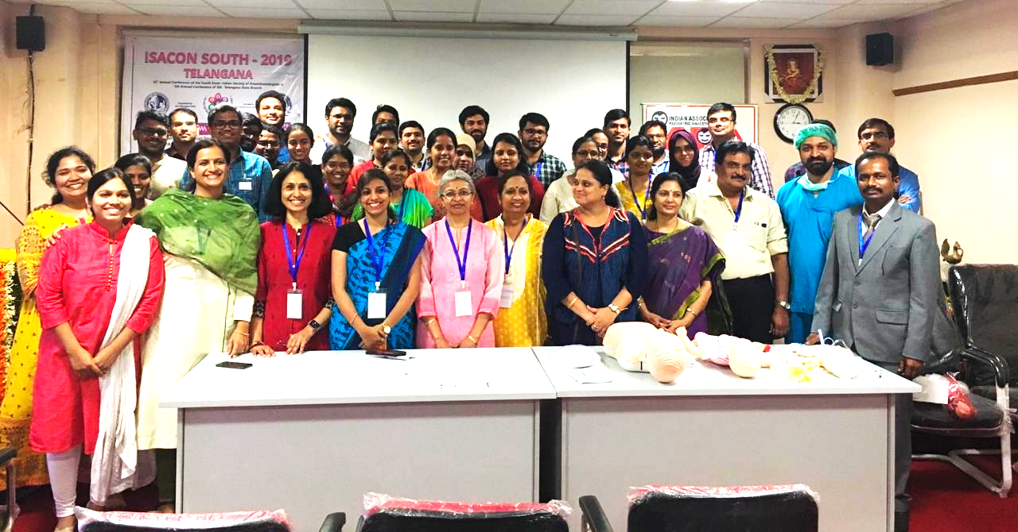
Group photo of all the faculty and delegates

