NEONATAL RESUSCITATION WORKSHOP BY IAPA TELANGANA STATE
DR.RAVI NAGAPRASAD
SECEATARY
IAPA, TELANGANA STATE
Our efforts to train the para- medical and nursing staff in the basic skills of neonatal resuscitation so as to reduce the mortality and morbidity in the new-borns, is a continuous and an unflinching one. We started an ambitious project of conducting “Neonatal resuscitation workshop & skill station” to all the nonmedical and nursing staff working in small and non-teaching maternity hospitals in the sub urban regions of Hyderabad.
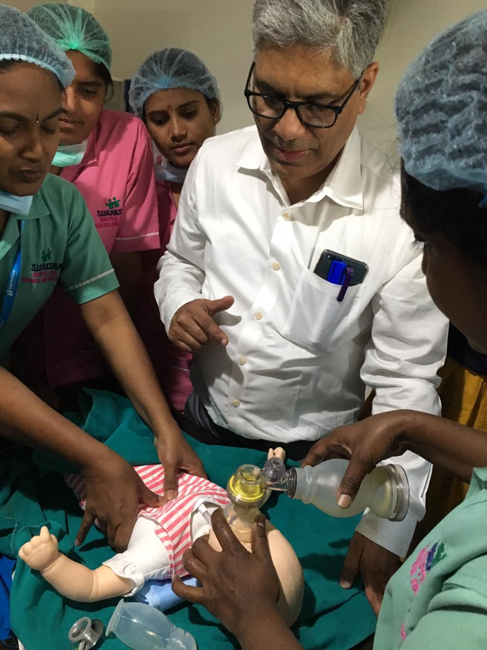
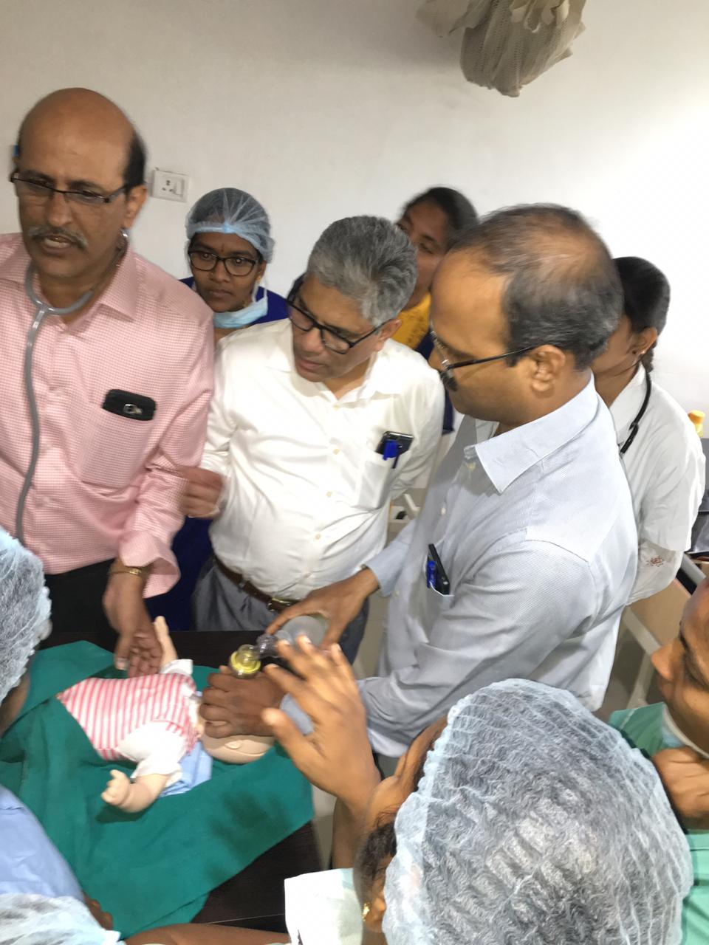
Our Workshop comprises of a short power point presentation, a video presentation of neonatal resuscitation, followed by a break up session and a skill station so that all the participants would have an opportunity of practising on manikins.
The session was well attended and well received by nursing staff. Buoyed by the enthusiasm for learning showed by the nursing staff we are planning to conduct similar neonatal workshops regularly in other peripheral centres in our state. A strict adherence of protocols framed by WFSA during resuscitation was stressed in the training. We were happy to find that their skills and knowledge improved significantly after the workshop.
Our sincere thanks to Dr.M.S.R.C Murthy and Dr.Aavula Muralidhar, IAPA National Executive body members, who took great efforts in coordinating with the local hospitals and organising the workshop. We are indeed indebted to WFSA for providing us Manikins and other equipment used in the workshop.

