ANAESTHESIA FOR BRONCHOSCOPY IN NEONATES – LMA ROLE
Dr Aavula Muralidhar, M.D., Associate Professor,
Dept.of Anaesthesiology, Niloufer Hospital, Osmania Medical College, Hyderabad, Telangana state.

INTRODUCTION
Requires special equipment and a sound knowledge of the anatomy, physiology and pathology of the pediatric airway which determine key differences between paediatric and adult bronchoscopy.
Always should be performed in a tertiary refferal centre. There Must be excellent communication between Anaesthesiologist and the Endoscopist to ensure that adequate oxygenation is maintained via the shared airway. Infant anatomy and physiology - Relative to the adult , the INFANT ‘s Tongue is large, epiglottis is longer and narrower and angled more posteriorly, are obligatory nasal breathers until 5 months. Larynx is softer, higher and more easily displaced. Tidal volume is fixed so respiratory rate must be increased to increase minute ventilation. FRC is less than the Closing capacity. Above all and high metabolic requirements in infant predispose to Hypoxia.

INDICATIONS
DIAGNOSTIC - Airway obstruction ( eg. Tracheo malacia), Persistent / recurrent pneumonia, TEF, Brushings for cytology, brushings for cytology, transbronchial biopsy for histology, failure to wean from ventilator and Haemoptysis. THERAPEUTIC – Removal moval of foreign body, Suctioning of mucus plugs eg. Cystic fibrosis, Facilitate endobroncheal intubation for one lung anaesthesia, Laser therapy, Balloon dilation of trachea / bronchus and Stent Insertion
BRONCHOSCOPES
Rigid bronchoscopy was developed in USA by Chavalier Jackson in 19th century. Slightly later in UK by Victor Naegus. Fibreoptic bronchoscope by Ikeda and colleagues in 1968.
Two main types - Rigid and Flexible. Rigid further divided into ventilating and venturi type. Correct size rigid bronchoscope allows a small leak at 20-25cm H2O. Air trapping is a potential hazard when controlled ventilation is used. Always assume BRADYCARDIA is secondary to hypoxia until proved other wise. Venturi bronchoscopes - Open ended metal tubes. Gas exchange is by jet insufflation of the lungs with oxygen and entrained air using a Sanders injector. Maintenance of anaesthesia has to be IV only , as inhalational agent cannot be delivered, nor is it possible to monitor gas delivery. Because of CO2 retention and increased risk of barotrauma, the technique should be limited to patients weighing >40 kgs

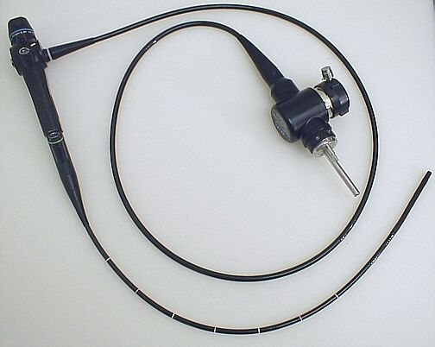

Fig 1. Flexible bronchoscope

Flexible bronchoscopes - Consists of bundle of fibreoptic fibres with magnifying lens system at the distal end. The tip of the bronchoscope can be angulated 160 degrees up and 90 degrees down using a steering wheel at its distal end and on most there are suction and injection ports. Spontaneous ventilation occurs around the instrument, hence it will be difficult for the patient to breathe if the scope size is too big. Smallest bronchoscope available is ED 1.8mm distally and 2.2 mm proximally ( Olympus BF N20). Can be introduced nasally or orally, commonly under local anaesthesia with sedation. Smaller diameter makes a steerable access to the distal airway possible. The field vision is greater with a fibreroptic than with a rigid one, this facilitates examination of the upper lobe and apical divisions of the lower lobe bronchi. Used mainly for diagnosis and as an aid to intubation in the child with a difficult airway. The LMA provides a safe route for anaesthesia and the insertion of flexible bronchoscopes while maintaining spontaneous ventilation with O2 and Sevoflurane.

Scope is passed through LMA via angle piece with a sealed port and LA is applied to the larynx through injection port and spray as you go inside. The ID of LMA allows the passage of a larger scope than ET tube. A disadvantage of LMA is that it can cause the vocal cords to appear immobile. Rigid bronchoscopy favoured for immediate preoperative location of tumors and surgical assessment and is the method of choice for extraction of foreign bodies and virtually all patients prefer general anaesthesia.
Fibreoptic bronchoscope can penetrate to the subsegmental bronchi and is now used routinely for all diagnostic procedures under local anaesthesia and sedation.

Contraindications
Moribund patients, Severe and advanced cardiac failure, In untreated myasthenia gravis,
Lesions of the cervical spine, where hyperextension of head might lead to compression of spinal cord.

Anaesthetic considerations
Preoperative assessment - Previous anaesthetic history / chart, Anaesthesia notes to know any difficulty faced during intubation , ET tube size used etc. Enquire about strider, RD and cyanosis in relation to position, crying and feeding. Strider only during inspiration suggests extrathoracic obstruction, if it is expiratory intrathoracic obstruction.
Specific investigations – chest X-Ray to localize an inhaled foreign body or a CT Scan to evaluate a possible cause for obstruction.
Preparation & Premedication - Variety of ET Tubes, Supraglottic airways, Laryngoscopes and Bronchoscopes should be availble. Monitoring – ECG, NIBP, SPO2 , Temperature and EtCO2. Intravenous access should be secured prior to induction, but if the child is distressed this can be performed immediately after induction. Written high risk consent. Premedication - Anxiolytic such as midazolam (0.5mg/kg orally). An anticholinergic has dual effect of preventing Bradycardia secondary to airway instrumentation, and antisialogogue effect. Steroid Dexamethasone 0.6mg/kg , to minimize airway oedema after instrumentation. Opioids – Fentanyl 2 µg/kg. NG Tube should be introduced for regular aspirations.
General Anaesthesia techniques - General anaesthesia with muscle relaxant or maintaining spontaneous respirations. The reason for bronchoscopy usually dictates both the method of anaesthesia and the type of bronchoscope used.
Requirements - To provide anaesthesia & analgesia, Sufficient relaxation, Abolition of reflexes from respiratory tract, Maintenance of adequate gas exchange, Rapid recovery of – consciousness, respiratory drive, cough reflex.
For induction and maintenance sevoflurane appears to be the best choice, as it is nonirritative, and even relatively high concentrations are comparatively well tolerated. Therefore, rapid induction is possible without coughing, laryngospasm and apnoea or haemodynamic instability. TIVA can be used to maintain anaestheisia - Propofol with or with out opioid as a technique of choice, providing good airway reflex suppression, rapid emergance and decreased pollution; can be used in new borns.

Medications used during procedure - We use NS in lavage cases. Lidocaine (1% or 2%) solution at a dose of 1 -2 mg /kg used either on the vocal cords or carina to minimize cough and bronchospasm. Hyper tonic saline, acetylcysteine and / or recombinent human deoxyribonuclease ( dornase-alfa) used in collapsed lung lobes to re-channelize airways. Albuterol inhaler and IV dexamethasone used during prolonged intervention to minimize airway constriction. Epinephrine used for a patient with haemorrhagic airway. BAL (Broncho Alveolar Lavage ) performed in patients with suspected respiratory infection (to determine microbe), Haemosiderosis, lipoid pneumonia, alveolar proteinosis, and in cases of unclear diagnosis. For localised leisons BAL performed only in the affected lobe, while with diffuse disease in the right middle lobe and lingual lobe. BAL performed with the use of NS warmed to body temp., a volume of 3 ml/kg in three divided doses in children less than 20 kgs. More than 20 kgs , 20 ml volumes injected. Approximately 40 – 70 % of fluids recovered by suction.
Complications - Particularly with rigid bronchoscope – trauma to the lips, teeth, base of the tongue, epiglottis and larynx ( commonly by inexperienced endoscopist). Damage to the tracheobronchial tree results in pneumothorax, pneumo mediastinum and surgical emphysema. Whatever method of anaesthesia is used there is an ever present danger of Desaturation / hypoxia, may occur despite presence of the side port and scope may need to be withdrawn repeatedly. Excessive suctioning will remove gases including oxygen and cause atelectasis. Bronchospasm can be secondary to irritation of the tracheobroncheal tree. Hypercarbia due to air trapping. Bradycardia – secondary to hypoxia / Airway instrumentation. During recovery strider secondary to subglottic edema – Nebulised epinephrine 1:1000 in a dose of 0.5 ml /kg., produces transient relief. IV Dexamethasone for strider , produces more sustained relief. Reintubation may required. There may be considerable bleeding following biopsy.
Post-op Recovery - ALWAYS LEAVE THE CHILD LITTLE CRYING AND COUGHING. Always nurse in lateral position. Nebulization with bronchodilators and / or steroids. Most important is Vitals monitoring regularly. Presence of senior intensivist in ICU.
Case history – 1
1 month old, 2.35kg female neonate presented with severe respiratory distress, SPO2 in room air less than 80%, with O2 support maintaining around 95%. Suspecting mucous plugs in the trachea and right upper bronchous. X-Ray chest / CT Scan showing consolidation of right upper lobe. Posted for diagnostic / therapeutic bronchoscopy.

Case history – 2

3 days old, 2.45 kg male neonate presented with severe respiratory distress, SPO2 in room air less than 50%, On ventilator maintaining around 95% with FiO2 50%. Suspecting Mucous plugs or Laryngomalacia/ Tracheomalacia. Posted for diagnostic / therapeutic bronchoscopy.

Fig 2. LMA Connected to pediatric circuit maintaining spontaneous respiration – can be used to facilitate fibreoptic bronchoscopy. With LMA its easy to administer Oxygen during bronchoscopy, Hypoxia can be prevented during procedure.

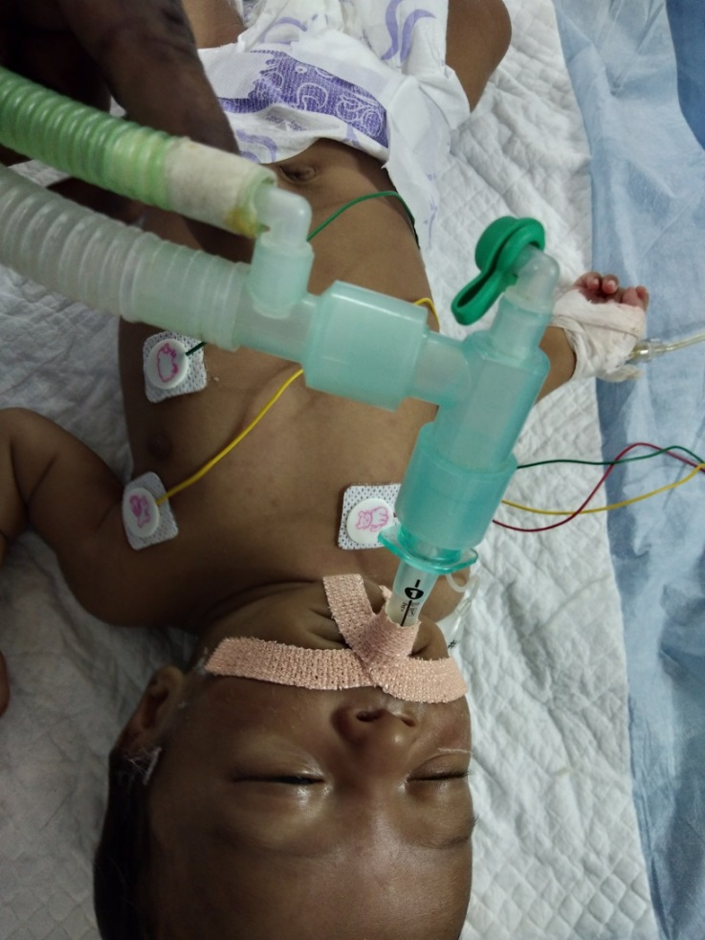

Fig. 3 & 4 Flexible bronchoscope through LMA – Its easy to introduce bronchoscope, administer Oxygen and also facilitates to visualize the glottic structure and to diagnose laryngomalacia.

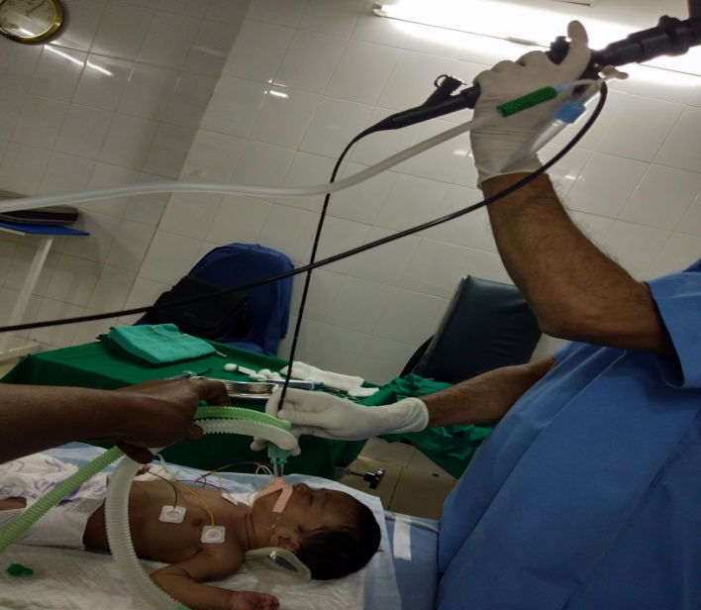
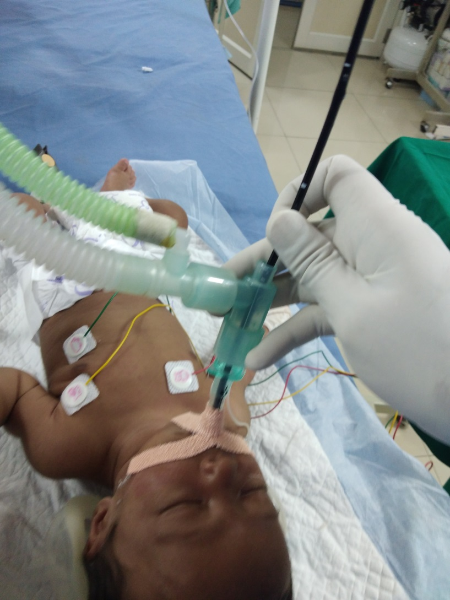

Fig. 5 Treating bronchospasm with nebulizer connected to angle piece of the circuit connected to LMA. It also easy to give 100% O2 with positive pressure to treat Laryngospasm.
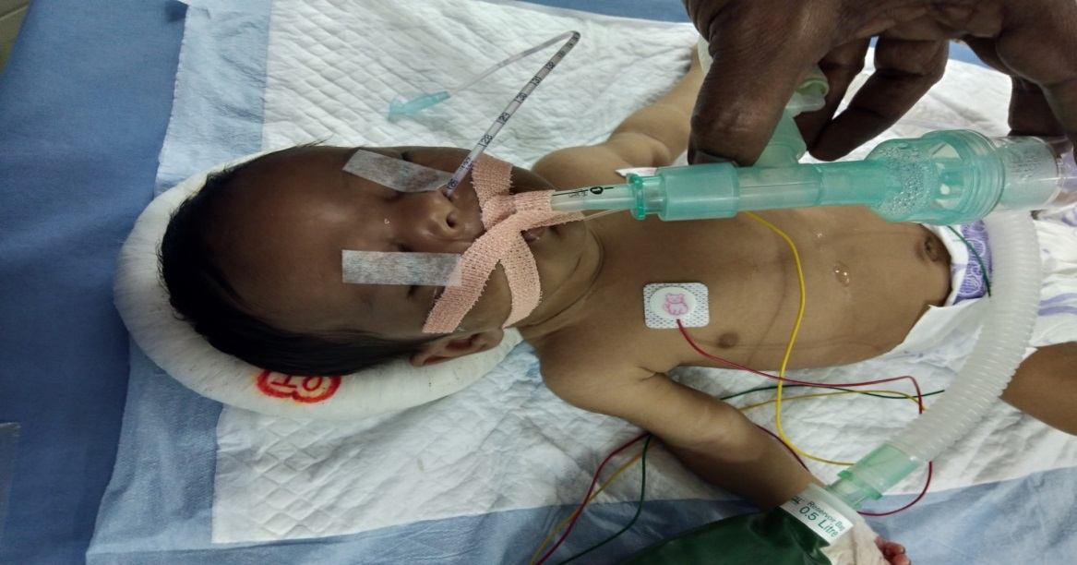
Fig. 6 Chest X – Ray PA View showing right upper lobe Atelectasis before bronchoscopy

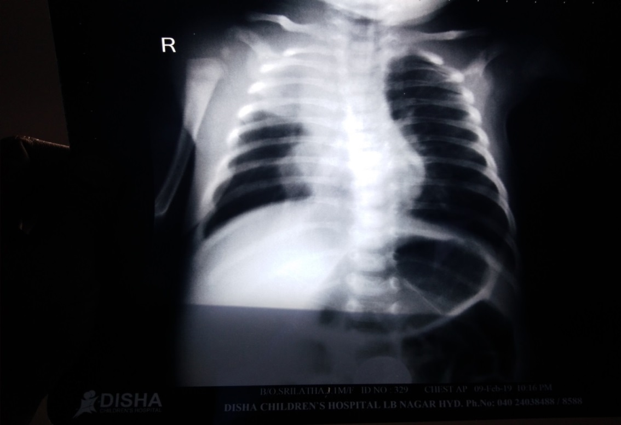

Fig. 7 After bronchoscopy - right upper lobe

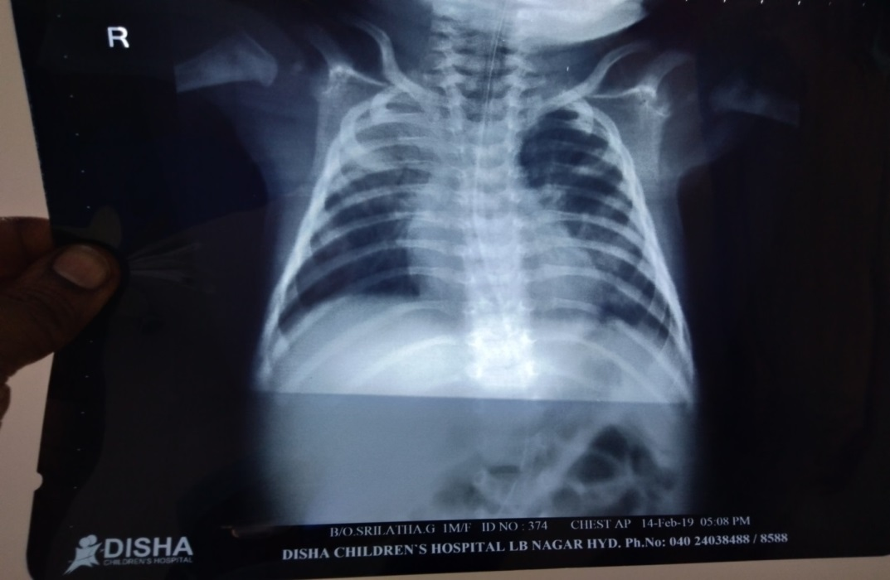

Conclusion
Advantages of using LMA for neonatal bronchoscopy comparatively with mask ventilation and / or ventilating bronchoscope are easy to tackle complications like Hypoxia ( will able to give directly 100% O2 easily ) Laryngospasm and Bronchospam ( connect the nebulizer directly to ayer’s T piece angle) and easy to instill drugs into the trachea.

